DADUS PRODUSAUN HARE TINAN 2025
Data Record on Production of Rise, by Year of 2025

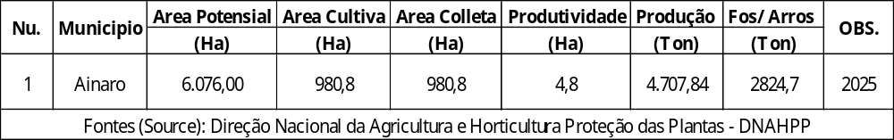
DADUS PRODUSAUN HARE TINAN 2025
Data Record on Production of Rise, by Year of 2025

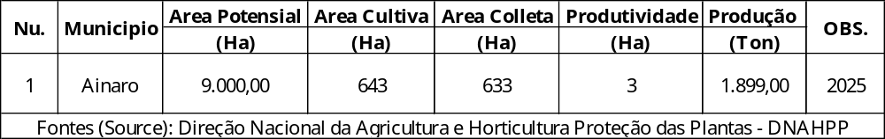
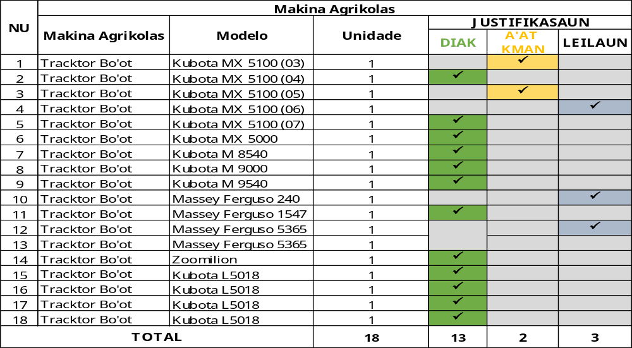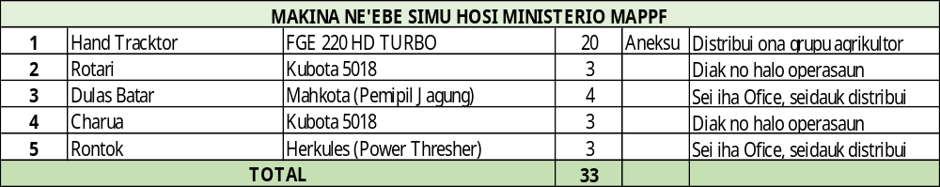

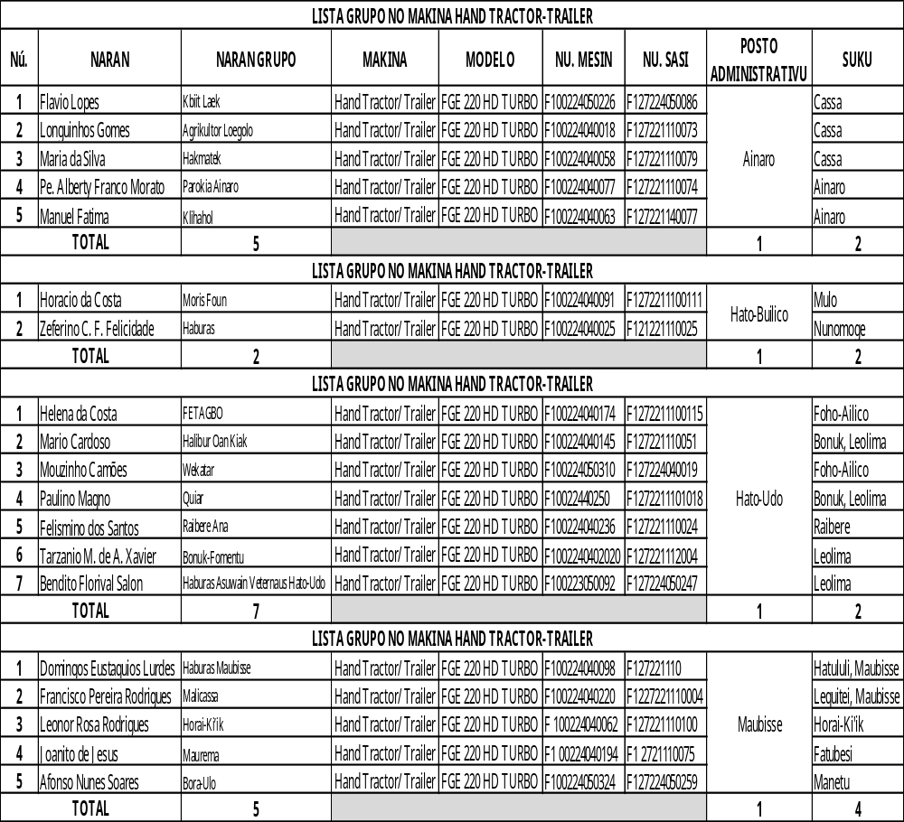

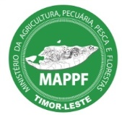
DIRECÇÃO NAÇIONAL VETERINÁRIA
Rabies Situation Report
Dados Vasinasaun Raiva ba Animal 2025
Iha tinan 2025, kampanha vasinasaun raiva hahu iha loron 13 de fevereiro 2025 – 26 de Setembro 2025, halao ona vasinasaun iha Municipio sira hanesan Bobonaro, Covalima, Dili, Liquiça, Ermera, Oecusse, Aileu , Ainaro no Manufahi ho total animal vasinadu 10.731 kabesa. Kompostu husi asu 10.432 vasinadu, busa 266 vasinadu, no lekirauk 33 vasinadu.
Tabela 1. Rezultadu Vasinasaun Raiva 13 de Fevereiro – 26 de Setembro 2025
Municipality | Administrative post | Dogs vaccinated | Cats vaccinated | Monkeys Vaccinated | % dogs vaccinated
Ainaro | Ainaro Vila | 715 | 4 | 2 | 88.7%
Ainaro | Maubisse | 1 |  |  | 100.0%
Sub-total: Ainaro |  | 716 | 4 | 2 | 88.7%
Aileu | Aileu Vila | 785 | 22 | 2 | 85%
Sub-total: Aileu |  | 785 | 22 | 2 | 85%
Bobonaro | Atabae | 337 | 13 | 1 | 88.0%
Bobonaro | Bobonaro | 346 | 4 |  | 86.01%
Bobonaro | Cailaco | 772 | 8 | 8 | 79.1%
Bobonaro | Lolotoe | 751 | 6 | 1 | 92.3%
Bobonaro | Maliana | 604 | 5 | 0 | 84.4%
Sub-total: Bobonaro |  | 2.810 | 36 | 10 | 85.4%
Fatululic 82 |  |  |  |  | 65.1%
Covalima | Maucatar | 102 | 2 |  | 73.4%
Covalima | Suai | 241 | 2 |  | 67.7%
Covalima | Tilomar | 134 | 2 |  | 62.9%
Sub-total: Covalima |  | 559 | 6 |  | 67.9%
Dili | Cristo Rei | 506 | 36 | 1 | 88.9%
Dili | Dom Aleixo | 887 | 51 |  | 80.3%
Dili | Metinaro | 1 |  |  | 100.00%
Dili | Nain Feto | 211 | 12 |  | 76.7%
Dili | Vera Cruz | 282 | 10 |  | 82.9%
Sub-total: Dili |  | 1.887 | 109 | 1 | 82.4%
Ermera | Ermera | 495 |  |  | 87.8%
Ermera | Railaco | 1.112 | 16 | 2 | 76.2%
Sub-total: Ermera |  | 1.607 | 16 | 2 | 79.4%
Liquica | Bazartete | 56 |  |  | 65.1%
Liquica | Likisá | 22 |  |  | 73.3%
Liquica | Loes | 1,099 | 28 | 15 | 72.9%
Liquica | Maubara | 63 | 8 |  | 50.0%
Sub-total: Liquica |  | 1.240 | 36 | 15 | 70.0%
Manufahi | Alas | 8 |  |  | 61.54%
 | Same Vila | 385 |  |  | 78.25%
Sub-total: Manufahi |  | 393 |  |  | 77.82%
Oecusse | Oesilo | 9 |  |  | 90.00%
Oecusse | Pante Macassar | 426 | 11 |  | 77.03%
Sub-total: Oecusse |  | 435 | 11 |  | 77.26%
Total | - | 10.432 | 266 | 33 | 80.47%

Tabela 2. Kazu raiva iha asu, 2025
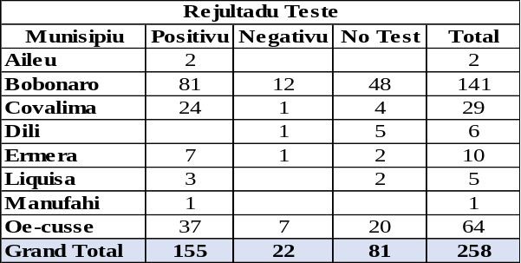

DADUS SERVISU DEPARTEMENTU PEKUARIA & VETERINARIA
- Vasinasaun
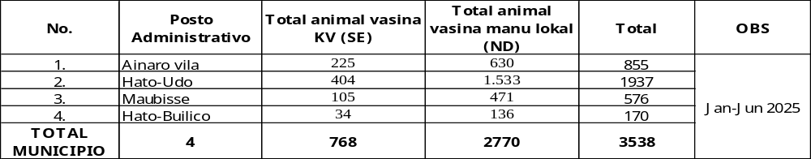
- Tratamentu
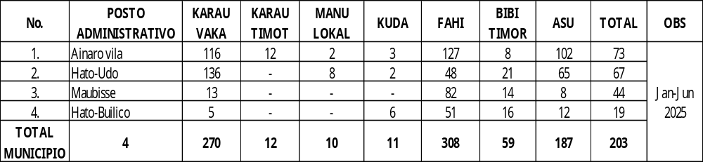
- Negosiu
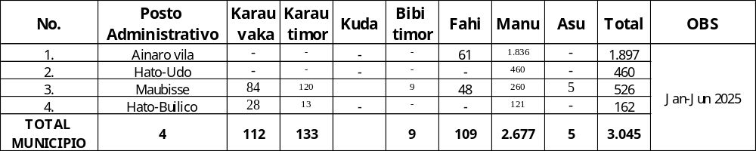
- Matadouro
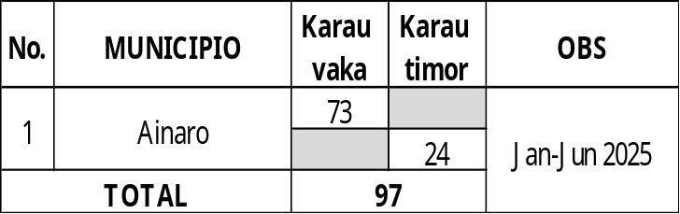
- Lisensa Animal (Transit)
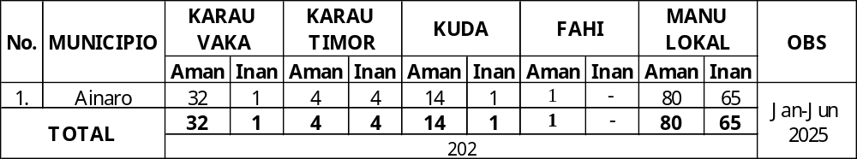

DADUS DELEGASAUN FLORESTAS
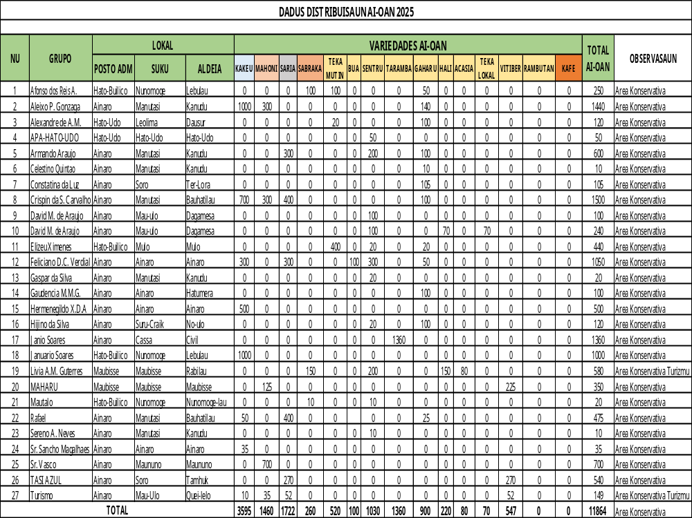

ATIVIDADE PARSEIRUS FAO
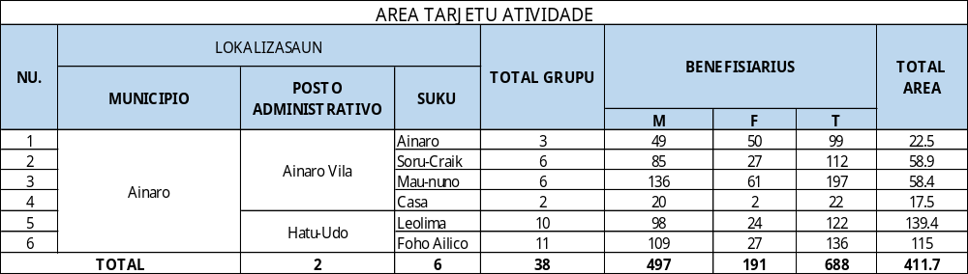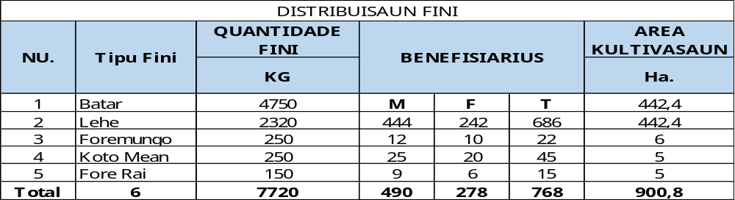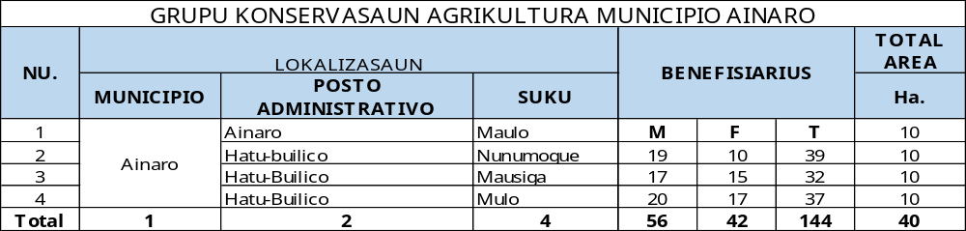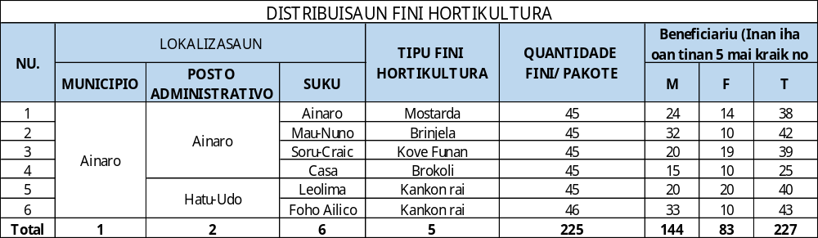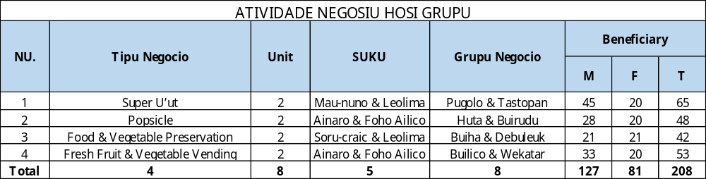
ATIVIDADE PARSEIRUS SAPIP
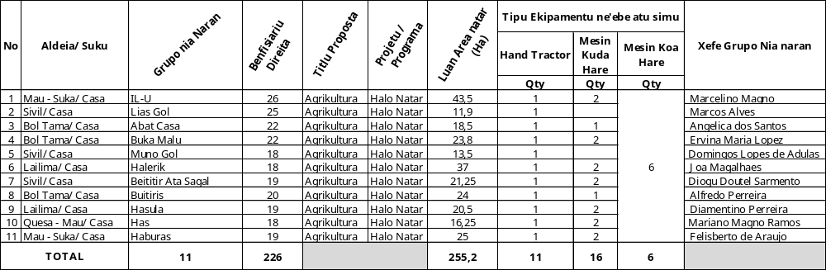
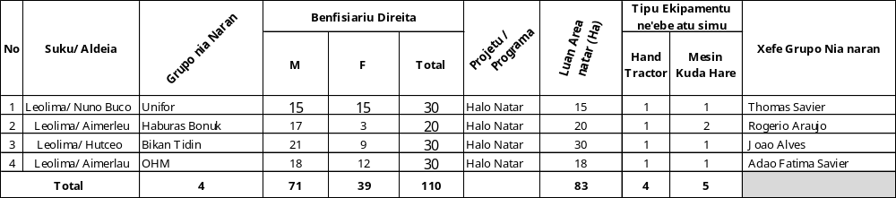
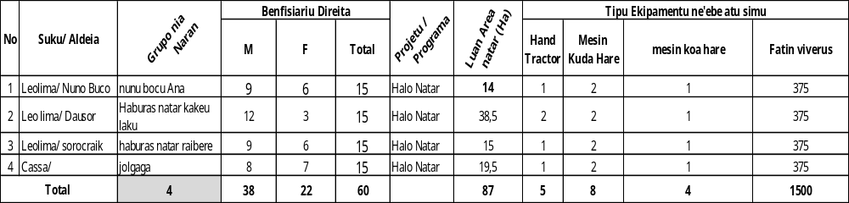
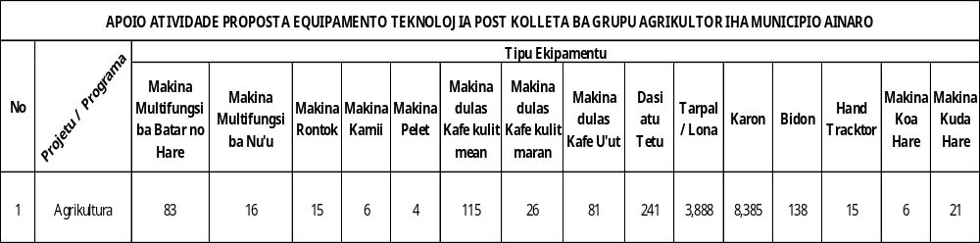
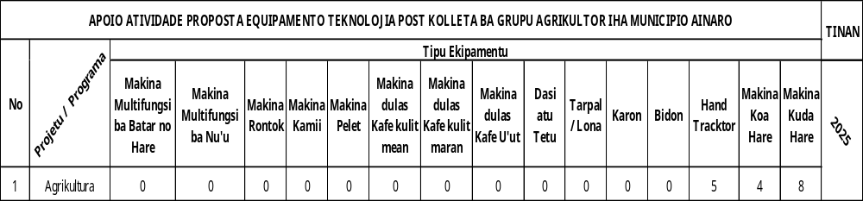
EZEKUSAUN MINA TINAN 2025
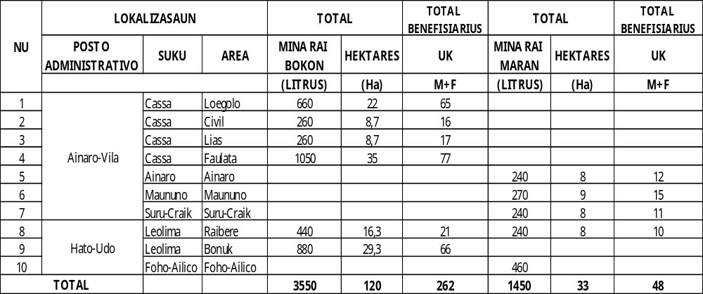
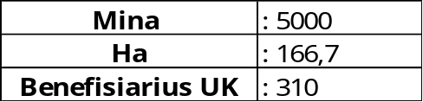
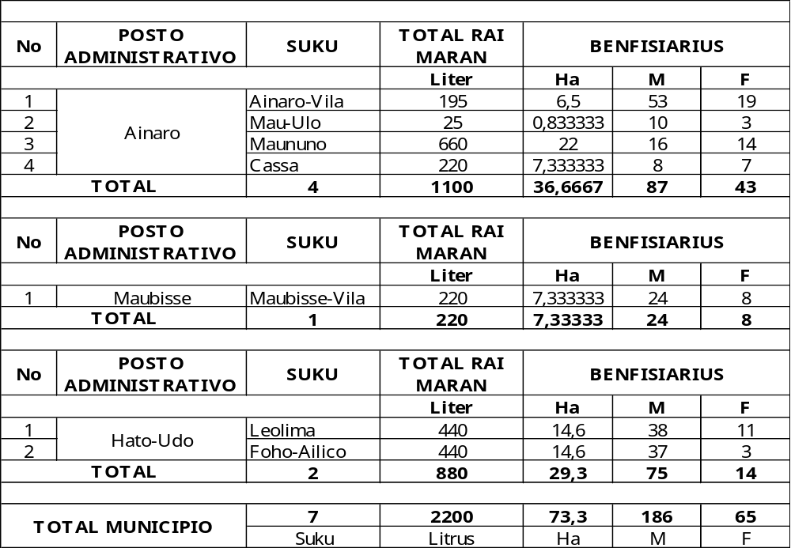
TOTAL MINA | 7220 Litrus | 2025
Benefisiarius | 561 | 2025

DISTRIBUISAUN FORE-RAI
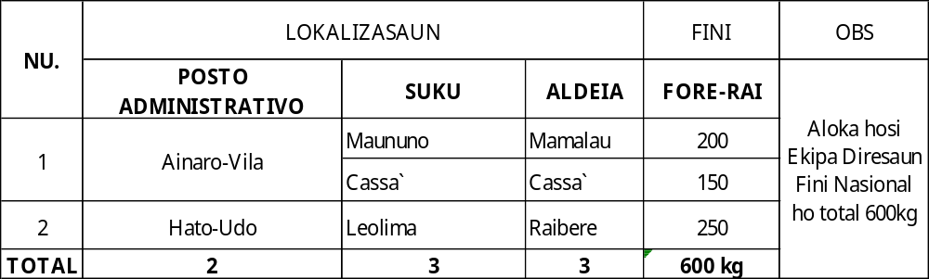
Forsa Traballu Servisu Agrikultura Municipio Ainaro
